Addition of Bromine (Br₂)
As mentioned above, saturated hydrocarbons will only react with bromine under free radical conditions, meaning you have to add UV light. So simply adding some bromine to cyclohexane won’t cause a reaction to occur. Aromatic hydrocarbons can react with bromine only in the presence of a strong Lewis acid catalyst such as FeBr₃- you’ll learn about this next semester (Carey CH 12.5). So simply adding some bromine to toluene won’t cause a reaction to occur. Cyclohexene will readily reacts with bromine (see Carey CH 6.15 and 6.16).
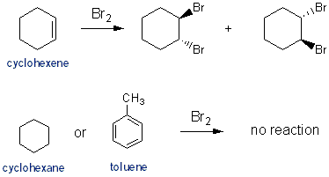

Reaction with Potassium Permanganate (KMnO₄)
Potassium permanganate reacts with anything unsaturated. KMnO4 reacts with alkenes to form vicinal diols (similar mechanism as with OsO₄, Carey CH 15.5). KMnO4 will also react with alkyl benzenes, such as toluene, to form benzoic acids (Carey CH 11.13). Although I don’t think any reaction will take place without adding heat. Alkanes won’t react with KMnO₄.
